Contents
Background 2
PeopleXD’s database security 2
HR Reporting’s folder-based security 2
The reporting folder hierarchy 3
Active Directory (“AD”) groups 4
Processes 5
Managing AD groups 5
AD group membership 5
Creating or deleting AD groups 10
Reporting super-groups 10
Managing folder security 11
Viewing folder security 11
Editing folder security 13
Folder security for subscription-based reports 15

Additional Guidance
Knowledge Article: Active Roles Web Interface Knowledge Article_v1.0.docx
HOW TO - Manage Reports - HR Reporting Environments.docx
HOW TO - Manage Reports - Change Processes in OSM.docx
HOW TO - Manage Reports - Release and Deployment.docx
HOW TO - Manage Reports - Parameters.docx
HOW TO - Manage Reports - Shared Data Sources.docx
HOW TO - Manage Reports - Shared Datasets.docx
HOW TO - Manage Reports - Troubleshoot Common Errors.docx
HOW TO - Manage Reports - Visual Studio Basics.docx

Background
The SSRS reports developed by the Functional Analysis and HR Analytics teams are stored in the various HR Reporting environments (DEV, TEST, QA and LIVE), where end-users may execute them as necessary. Two levels of security apply to every report: PeopleXD’s database security and HR Reporting’s “folder-based” security.

This how-to guide only addresses how to manage security within the HR Reporting environments. A brief note on PeopleXD’s database security is included for context.

PeopleXD’s database security
When a report query is executed, PeopleXD’s native security model is applied to the data within each .RDL file. This means that a given end-user will only be able to retrieve results which they have permission to view, based on the roles assigned to them within PeopleXD’s Security module. Security can apply to areas of the business, such as departments and divisions, or specific types of data, such as salary information.

Example: A user with permission to view all data in their current department runs a report. PeopleXD’s database security ensures that when the user runs the report, they only retrieve results for their own department.

Example: A user with permission to view data for Pay Group 20 (but not Pay Group 21) runs a report. PeopleXD’s database security ensures that when the user runs the report, they only retrieve results for Pay Group 20, and not Pay Group 21.

 | NB: Questions about Core’s database security must be handled by the HRIS Functional and Configuration Analyst (Michael O’Sullivan), who can confirm the security in place for individual users and amend it if required.

HR Reporting’s folder-based security
A second level of security has been imposed in the HR Reporting environments themselves, to ensure that users only see reports which are relevant to their line of work – for instance, a departmental user has no need to view Payroll or Pensions reports, but a Payroll user may need to view departmental reports.

This second level of security is “folder-based”. All the .RDL files in the HR Reporting environments are stored within a folder hierarchy, and each level of the folder hierarchy is shared with certain groups of users, depending on their reporting requirements. These user groups are managed via the Active Directory, and are therefore known as “AD Groups”. An AD group’s access to any level of the folder hierarchy is dependent upon the folders within that level being shared with the AD group.

Some contextual information about AD groups and the reporting folder hierarchy is given below.

The reporting folder hierarchy

The folder hierarchy is generically illustrated here:

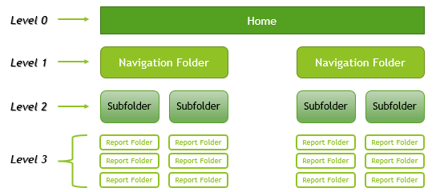

Level 0 – Home: A user must have access to the Home folder of the reports server in order to access any of the folders or files located on the server. Access to the Home folder is assigned on the folder’s security profile. If a user is a member of an AD group assigned to the Home folder, then that user will be able to access the reports server. Their access to the folders and files within the reports server depends on whether an AD group of which they are a member has been assigned to a given folder/file.

 | Access to the Home folder is like having the key to the front door of a building. All the rooms in the building are locked and require their own keys, but a user must be able to get into the building itself before they can access individual rooms within it.

Level 1 – Navigation Folders: Once a user has accessed the Home folder, they can navigate to the reports they need via the Navigation folders. The Navigation folders contain broad groupings of reports according to their main audience and/or purpose, e.g. “Payroll” or “Recruitment”. If a user is a member of an AD group assigned to a Navigation folder, then that user will be able to see the Navigation folder listed within the Home folder, and will be able to enter the Navigation folder to view its contents.

Level 2 – Subfolders: Once a user has entered a Navigation folder, the report they need may be present in a Report folder, or in a Subfolder. Subfolders are used to split very broad groups of reports into more granular categories; for instance Level 1 Personnel folder has three Level 2 subfolders: Current Reports, Monthly Reports, and Tracking Reports.

Not every Navigation folder has Subfolders; however, where Subfolders exist, the same rules of access apply. To wit, if a user is a member of an AD group assigned to a Subfolder, then that user will be able to see the Subfolder listed within the Navigation folder, and will be able to enter the Subfolder to view its contents.

Level 3 – Report Folders: Once a user has accessed a Navigation folder (or Subfolder, if applicable), they must select the report they wish to run by going to the appropriate Report folder. The Report folder contains the .RDL files which make up a report; a report may be comprised of one or many .RDL files. So long as a user is a member of an AD group assigned to a Report folder, then that user will be able to see the Report folder listed within the Navigation folder (or Subfolder, if applicable), and will be able to enter the Report folder and access the .RDL files within it.

 | Note: Security is not applied at the level of individual .RDL files. If a user has access to a Report folder, they have access to all the .RDL files within that folder.

Active Directory (“AD”) groups
An AD group is simply a collection of CONNECT accounts belonging to individual users. Each group is given a semi-descriptive name indicating its membership. Some examples of AD groups include:

Group | Members
HRIS-RR-PAYMREP | Managers of the Payroll team
HRIS-RR-EDU_TEAM | The Equality & Diversity team
HRIS-RR-SUP_REP | The HR Systems Support team

Individuals are added to AD groups via the Active Roles web interface, and AD groups are then assigned to folders within the HR Reporting environments. When an AD group is assigned to a folder, all the individual members of that AD group will be able to access the folder and all of its contents.

Most AD groups are only assigned to a handful of folders – for example, the EDU_TEAM group only has access to folders which contain equality & diversity-related reports. Some AD groups, however, are assigned by default to every folder within the folder hierarchy. These groups are known as the “reporting super-groups”, and they are as follows:

Super-Group | Members
HRIS-RS-PowerBI Report Writers - Production | People with read/write access to the entire LIVE environment
HRIS-RS-PowerBI Reporting Support - Production | People with read-only access to the entire LIVE environment
HRIS-RS-PowerBI Report Writers - Non Production | People with read/write access to the QA, TEST and DEV environments
HRIS-RS-PowerBI Reporting Support - Non Production | People with read-only access to the QA, TEST and DEV environments
HRIS-RS-PowerBI Reporting Administrators - Non Production | IT staff who can manage the HR Reporting environments

The super-groups have full access to the HR Reporting environments (either LIVE or non-LIVE, as shown above). Membership of these groups is managed by the Microsoft Platform Services Team.

Processes

Managing AD groups
Since access to levels of the reporting folder hierarchy is managed through AD groups, you may need to review the membership of an AD group, add new members, remove existing members, or even request the creation of a new AD group entirely.

To do any of these things, you will need to access the Active Roles web interface.

 | Note: Only the HRIS Functional Analysis team should have read-write access to the Active Roles web interface; this is to ensure the careful management of access to the HR Reporting environments.

AD group membership
To view the members of an AD group, navigate to the Active Roles web interface. On the landing screen, select Search.

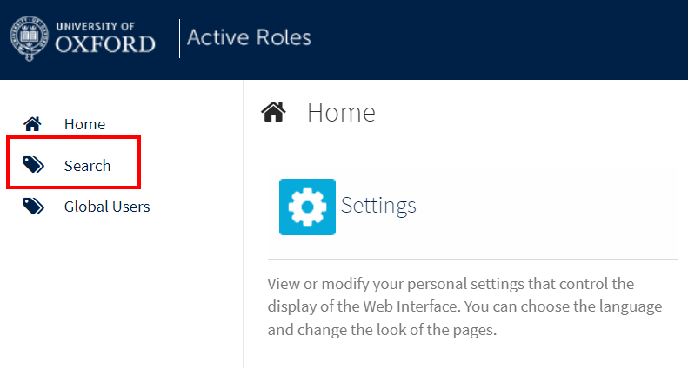

Search for the name of the AD group you wish to view, e.g. HRIS-RR-EDU_TEAM. If you are not sure of the exact name of the AD group you’re looking for, simply search for “HRIS-RR-” to retrieve the full list of AD groups:

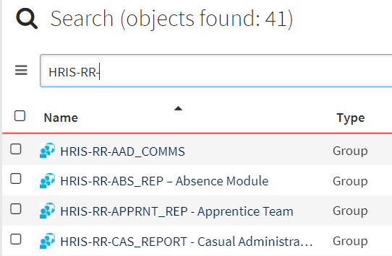

Select the group you need, and in the right-hand menu bar, select “Members”:

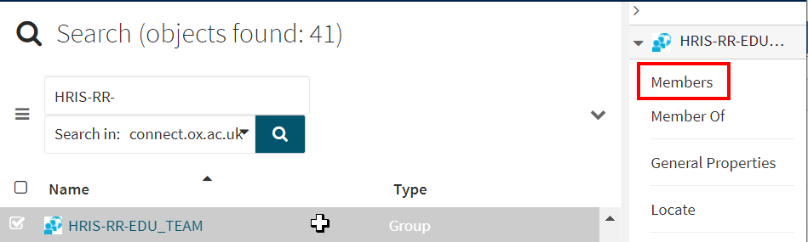

The list of individual members will be displayed:

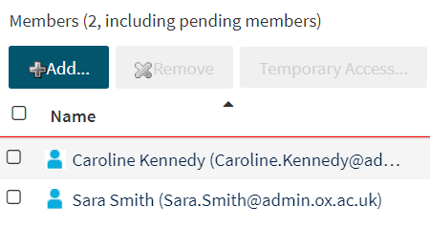

Adding members to an AD group
If you need to add a new member to an AD group, navigate to the group and click “Members”, as shown above. On the member list screen, click “Add…”:

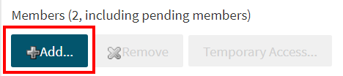

A pop-up window will open. Search for the name or the SSO of the person you wish to add to the AD group:

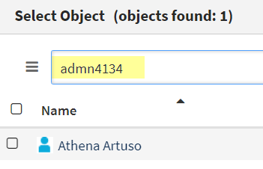

 | NB: The Active Roles web interface will only display users who have CONNECT accounts. If the person you are searching for does not appear in the Select Object pop-up window, it’s possible that they do not have a CONNECT account. Speak to the HRIS Functional and Configuration Analyst (Michael O’Sullivan) if you think this might be the case. If necessary a CONNECT account can be created for the individual.

Once you’ve found the person you want to add to your AD group, click the tick-box next to their name to select their record.

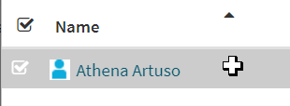

Click OK to confirm your choice. The pop-up window will shut and the new person will appear in the list of AD group members:

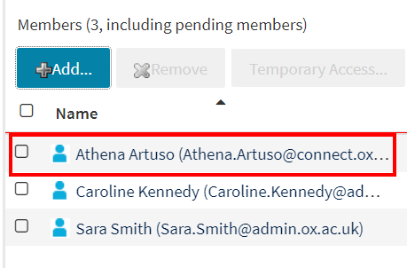

Removing members from an AD group
To remove members from an AD group, navigate to the group and click “Members”. On the member list screen, click the tick-box next to the name of the person (or people) you wish to remove:

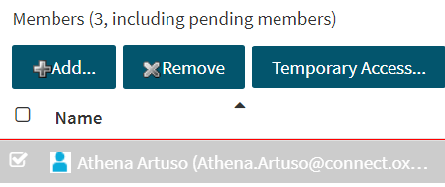

Click “Remove”. A pop-up warning will appear:

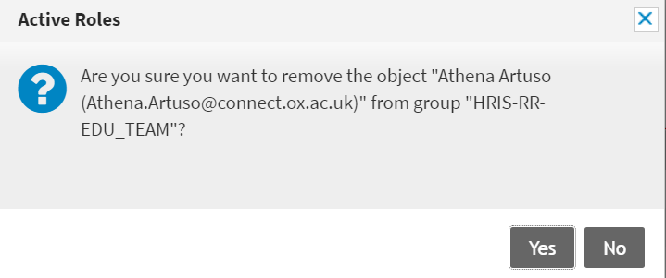

Click “Yes” to confirm your choice. The pop-up window will shut and the person will be removed from the list of AD group members:



Temporary access
It is possible to grant users temporary membership in an AD group – this is sometimes done when e.g. project teams need access to the HR Reporting environments for a limited period of time.

If you need to grant a user temporary access, navigate to the AD group and click “Members”. On the member list screen, click “Add”. Search for the individual’s record in the pop-up window and click the tick-box next to their name to select their record. You will see at the bottom of the pop-up window, there is a button labelled “Temporary Access”:

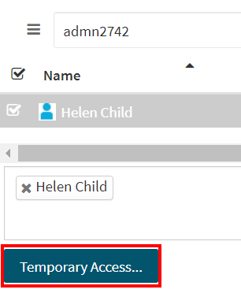

Click the button to open the Temporal Membership Settings window. Here, you can set start and end dates for this user’s membership of your AD group. By default, all AD group members are set to “Start: Now” and “End: Never”. You can enter whatever dates you require for members who only need temporary access:

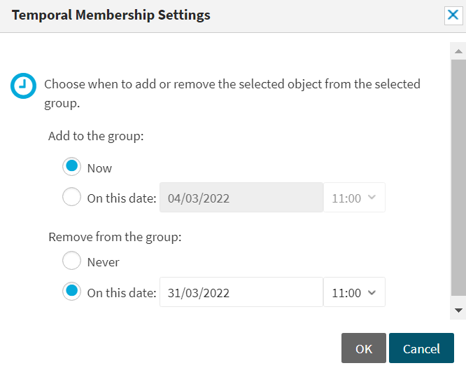

Click OK to confirm your choice. The pop-up will close and the person will be added to the AD group’s membership list. You can see that they have temporary membership from the little icon next to their name – a silhouette with a small clock next to it:

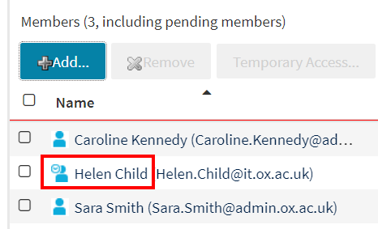

Creating or deleting AD groups
The steps above outline how to manage existing AD groups, but you may occasionally need a new AD group to be created, or a defunct AD group to be deleted.

While the HRIS Functional Analysis team is able to manage AD group membership, it is not able to create or delete actual AD groups from the Active Roles web interface – this work is handled by the Microsoft Platform Services Team (MPST).

Requests for the creation of new AD groups must be raised on OSM as Minor Changes and a task must be assigned to MPST with details of the new group. These details must include:
- Group name – this must be in the format “HRIS-RR-[short descriptive group name]” .
  - Example: HRIS-RR-FINANCE_BFT
- Description – a description of the group you wish to create.
  - Example: Finance Budgeting & Forecasting Team

MPST will create the group profile, and the HRIS Functional Analysis team can then add individual staff members.

Similarly, requests for the deletion of defunct AD groups must be raised on OSM as Minor Changes and a task must be assigned to MPST with the group name and the reason for deletion.

 | Note: Deleting an AD group will immediately deprive that group’s members of access to the reporting folder hierarchy. You must obtain written approval from Simon Burford and/or Mandy Zaccheo prior to requesting the deletion of existing AD groups.

Reporting super-groups
The reporting super-groups were listed above and are listed again here.

Super-Group | Members
HRIS-RS-PowerBI Report Writers - Production | People with read/write access to the entire LIVE environment
HRIS-RS-PowerBI Reporting Support - Production | People with read-only access to the entire LIVE environment
HRIS-RS-PowerBI Report Writers - Non Production | People with read/write access to the QA, TEST and DEV environments
HRIS-RS-PowerBI Reporting Support - Non Production | People with read-only access to the QA, TEST and DEV environments
HRIS-RS-PowerBI Reporting Administrators - Non Production | IT staff who can manage the HR Reporting environments

These groups have full access to the HR Reporting environments (either LIVE or non-LIVE, as shown above). Membership of these groups is managed by the Microsoft Platform Services Team – they are not visible in the Active Roles web interface, so if you need to make any changes to super-group membership, you will have to raise a task to MPST on OSM, specifying which group you want to change and which members should be added to / removed from the group.

 | Note: Because the super-groups have total access to all reports, membership must be managed extremely carefully to prevent possible data breaches.  All changes related to super-group membership must be approved in writing by Simon Burford, Athena Artuso, or Mandy Zaccheo, prior to being raised as Minor Changes in OSM, where they will be subject to formal approval by the Head of HR Systems.

Managing folder security
Access to the different levels of the reporting folder hierarchy is controlled by assigning AD groups to each level.

- Some AD groups have broad access, e.g. the PAYMREP (Payroll Managers) group can view the Payroll, Pensions, and Personnel Navigation-level folders, and all of their contents.
- Most AD groups have very limited access, e.g. the PERDREP (Personnel administrators) group can only view the Personnel Navigation-level folder and its contents.

You can review and amend the AD groups assigned to any level of the reporting folder hierarchy by following the steps below.

 | Note: Access to a folder’s contents must be tightly controlled to prevent possible data breaches. Any change to folder security must be managed as a Minor Change on OSM and formally approved by the Head of HR Systems.

Viewing folder security

Navigate to: Folder > Manage Folder > Security

From the HR Reporting environment’s Home page, navigate to the folder whose security you wish to review. In the menu bar at the top of the page, click “Manage folder”:

You will be taken to another screen. In the left-hand menu pane, select “Security” to view the security in place for the current folder:

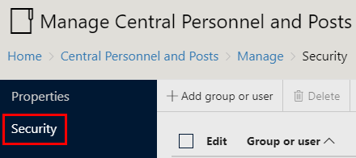

A list of the AD groups which have access to the folder will be displayed:

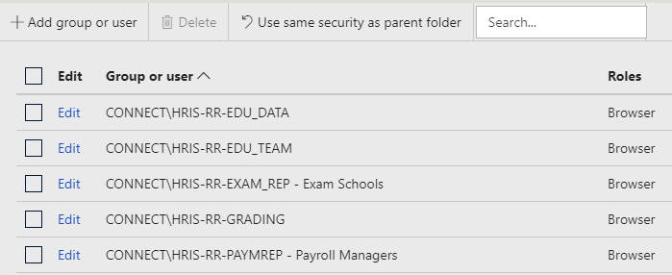

The “Roles” column indicates the level of access each AD group has to the contents of the folder.

Role | Level | Description
Browser | Read-only | May view folders and reports and subscribe to reports.
Content Manager | Read/write (full server) | May manage content in the Report Server. This includes folders, reports and resources.
My Reports | Read/write (restricted area of server) | May publish reports and linked reports; manage folders, reports and resources in a user’s My Reports folder.
Publisher | Read/write (full server) | May publish reports and linked reports to the Report Server.
Report Builder | Read-only | May view report definitions.

 | Note: AD groups should only ever be assigned the Browser role (read-only). Users who need read/write access must be added to special “super-groups” by the HR Functional Analysis team. See the linked Knowledge Article for details.

Editing folder security

Navigate to: Folder > Manage Folder > Security

Adding a new AD group
To add a new AD group to a folder within the HR Reporting folder hierarchy, navigate to the folder’s security screen and click the “+Add group or user” button at the top of the screen:



The New Role Assignment screen will open. Enter the name of the AD group you wish to add to the folder, and select the “Browser” role:

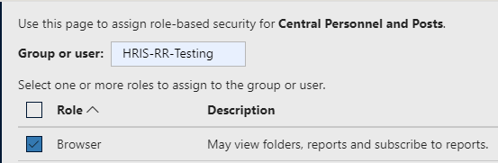

Click OK to save your changes and be taken back to the main security screen. The AD group you have just added will appear in the list of groups which have access to the folder:

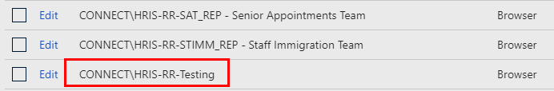

 | Note: You must ensure that your new AD group is added to every level of the folder hierarchy, or members of the AD group will not be able to access the folder!  Home  > The appropriate Navigation folder  > > The appropriate Subfolder (if applicable)  > > > The appropriate Report folder.

Removing an AD group
To remove an AD group from a folder within the HR Reporting folder hierarchy, navigate to the folder’s security screen and select the group you wish to remove. Click the “Delete” button at the top of the screen:

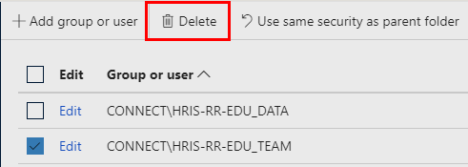

A warning message will pop up; click OK to confirm your changes.

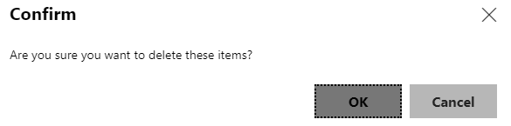

The screen will refresh and the AD group you have deleted will no longer appear in the list of groups with access to the folder.

 | Note: Depending on how far you need to restrict access, you may need to remove the AD group in multiple levels of the hierarchy.  For instance, if an AD group had access to Home > Navigation > Subfolder > Report, and should no longer have access to Navigation > Subfolder > Report, you will need to remove it from the Navigation folder and the Subfolder, as well as the Report folder.

Folder security for subscription-based reports
A tiny number of reports within the HR Reporting environments are run on a “subscription” model, in which a report user “subscribes” to a report and the report is run automatically on the user’s behalf by the REPORT_POWERBI Service Account.

The Service Account has unlimited user sessions and unrestricted access to PeopleXD’s database, so it must be kept highly secure to prevent unwanted data breaches. This means that it will only be used to run reports in exceptional circumstances – namely, when a report consistently times out or fails to complete when run by an ordinary user.

An explanation of the special security measures for subscription-based reports is given below.

The Subscriptions folder

Navigate to: Home > Subscriptions

All subscription-based reports must be filed in a special Navigation folder called (unsurprisingly) “Subscriptions”. Access to this folder is tightly controlled to prevent unauthorised users from viewing any subscription-based reports. Only the HR Reporting “super-groups” and subscription-specific AD groups should be assigned to the Subscriptions folder.

If you have created a new subscription-based report, you must create a Report folder for it within the Subscriptions folder; for example Home > Subscriptions > PAYPAY25 National Minimum Wage Check:

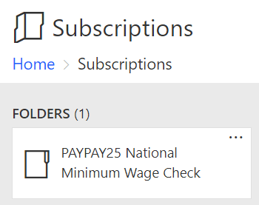

Each Report folder within Subscriptions must only be shared with a single AD group, comprised of the user or users who have subscribed to that particular report.

Subscription-specific AD groups
Whenever you set up a subscription-based report, you will need to create a new AD group for the subscribers. As noted above, requests for the creation of new AD groups must be raised on OSM as Minor Changes and a task must be assigned to MPST with details of the new group. These details must include:

- Group name – this must be in the format “HRIS-RR-SERVICE_[Report prefix]
  - Example: HRIS-RR-SERVICE_PERX14
- Description – this must always be “Report run by the Service Account”.

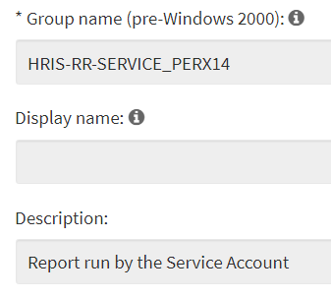

MPST will create the group profile, and the HRIS Functional Analysis team can then add individual staff members.

 | Note: To prevent the possibility of data breaches, you must ensure that only those staff members who have subscribed to the report are added to the new AD group.

Once the new subscription-specific AD group has been created and you have added the necessary members to it, you can add the AD group to the following folders:

- Home
  - Subscriptions
    - Report folder within Subscriptions

